# Intraspecific variability in germination responses of water-limited alpine/High Mediterranean Mountains environments.

Abstract

## 1. Introduction

Intraspecific variability plays a key role in determining a wide range of biological processes, from individual fitness to population dynamics, species interactions, community assembly and ecosystem properties (Westerband 2021). The intraspecific variation could be a response to highly variable heterogeneous environments (van Kleunen 2005) and it is an indispensable condition for plants to adjust to novel environmental conditions (ref). The adjustment primarily comes from two non-exclusive mechanisms: (1) the development of local adaptations (i.e. adaptive evolution) and (2) the unfolding of phenotypic plasticity (i.e. acclimatisation) (Nicotra 2010, Reed 2011). Adaptive evolution is a transgenerational/long-term process (ref) that widens the species’ potential niche, nevertheless, each locally adapted population has limited conditions in which they can survive, thus becoming more sensible to local threats (ref). In this situation, phenotypic plasticity may be the key to quick plant responses to new conditions (Matesanz et al., 2010; Walck et al., 2011, Nicotra et al., 2010; Reed et al., 2011) as can also act as a buffer to track environmental changes (Lando 2009, Chevin 2010).

In recent years, the importance of the seed regeneration niche and its integration within vegetation ecology has become more evident (Larson & Funk 2016; Jiménez-Alfaro et al. 2016). Successful reproduction by seed will determine if a species will be able to persist or migrate (F-P, 2019) while adaption or acclimatization processes are potentially taking place considering the ample intraspecific variability found in seed traits (Cochrane et al. (2015). There is a consensus that temperature and moisture are two of the main abiotic factors driving seed germination (Baskin & Baskin 2014). Thus, integrating temperature and water availability is a standard and useful approach (i.e. hydrothermal time) to characterize the germination niche Allen et al. 2000; Bradford 2002; Bewley et al. 2013). For germination to happen temperatures must remain within certain thresholds and water availability must surpass a specific level (i.e. base water potential, ψb) (Ref). Low water availability inhibits several physiological processes that lead to delayed or even impeded germination (Baskin & Baskin 2014), Sumner and Venn 2021). Comparatively to temperature, few studies have tackled how germination responds to water stress in detail (Bernau 2020). Most information about drought effects on germination proceeds from studies on arid ecosystems (e.g. Cochrane et al., 2014; Gelviz-Gelvez 2020; Yi 2019); there, responses vary notably depending on species (Kos & Poschlod, 2008) and even within species (Yi 2019).

The alpine environment is a particular biome specially threatened by climate warming. International records show higher temperatures increases rates (REF) that could potentially disrupting biological processes like plant phenology (F-P, 2019) and other plant regeneration processes like germination (Probert, 2000, Walck et al., 2011). The high topographic complexity observed at fine scales (Scherrer & Körner 2011; Graham et al. 2012; Körner 2021) has been seen to partially buffer temperatures increases (Körner & Hiltbrunner 2021) through communities shifting distributions (paper picos 2024). Nevertheless, the effects derived of unpredictable precipitation and earlier snowmelt which could result in water stress during summer (Hanssen- Baeuer et al., 2017) still need to be evaluated. Alpine germination studies have been mostly focused on the effect of temperature/warming on germination (e.g. Mondoni et al. 2012; Hoyle et al. 2015; Fernández-Pascual et al. 2021) as moisture is not considered a limiting factor (Ref) in the temperate regions, although recent research report that germination is specifically triggered by high soil moisture (Rosbakh et al. 2022). To study the effects of water stress in germination, likely more extent in the near future, the High Mediterranean mountains are an ideal example of alpine areas with a two-month drought period in summer (ref). Another limitation of alpine germination studies is that are mostly focused on population and community levels (e.g.Cavieres & Arroyo, 2000; Giménez-Benavides, Escudero, & Pérez-García, 2005; Shimono & Kudo, 2005; Wagner & Simons, 2009), but very few have investigated responses variation at subpopulation level (Gya et al., 2023) and even less considering the mosaic of microclimatic conditions at microscale (Scherrer & Körner 2011).

Here we aim to tackle two understudied topics in alpine grasslands communities of High Mediterranean mountains. Our study has the double objective to investigate (1) germination responses in water-limited alpine High Mediterranean Mountains and (2) the intraspecific variability of germination responses to water stress at the microscale level. The specific research questions are: (1) Will seeds from warmer (i.e., drier) subpopulations germinate better under higher water stress levels (i.e. lower water potentials)? To calculate hydrotime models we need non-dormant seeds, however, some oromediterraneous species are known to have some level of dormancy alleviated by after-ripening. No previous studies (to our knowledge) addressed this question in *Dianthus langeanus*, thus a second questions arises that needs to be answered first (2) Does the seeds' storage time (fresh vs. after ripened seeds) modify their response to water stress? We hypothesize that we will not find germination differences between storage treatment (results: fresh seeds have higher variability of germination responses and germinate worse) and that seeds from warmer/drier subpopulations will germinate better and faster at higher levels of water stress (results YES). To test our hypothesis, we conducted a growth chamber experiment to investigate subpopulation-level intraspecific variation of germination to water stress. The results can help us understand how germination will respond to future climate change scenarios in alpine habitats where precipitation is expected to become more unpredictable (Hanssen- Baeuer et al., 2017).

## 2. Methods

### 2.1. Study system

This study focuses on *Dianthus langeanus* Wilk. (Caryophyllaceae), a wild carnation endemic to the mountain systems of the northwestern Iberian Peninsula (shadowed area in Fig 1A, adapted from Rocha et al 2017). *D. langeanus* Wilk (Caryophyllaceae) mainly lives in open dry grasslands on acid soils (Fig 1B), where it can be locally abundant. Previous experiments indicate flowering onset in early June (Fig 1C), and ripe seeds are dispersed during August; it has high seed production usually >10 seeds per capsule and up to 250 seeds per individual (own field data collected). Germination occurs mainly during end-summer/early autumn at high rates and with high success when water is available at temperatures ranges of 10 – 22 ºC (move along paper). We studied wild populations of *D. langeanus* in the northern limit of its distribution, in the Valles de Omaña and Luna Biosphere Reserve, in the southern ranges of the Cantabrian Mountains (Fig 1A, red square). The Cantabrian Mountains run E-W in northern Spain along 480 km in parallel to the Cantabrian Sea …. This mountain hub encloses summits above 2,500 m a.s.l and the treeline in acids soil climbs up to 1650m a.s.l (ref TFM Jorge). It is considered a transitional biogeographical hub between the Eurosiberian and Mediterranean regions (Jiménez-Alfaro et al. 2021), influenced by Mediterranean climate on the southern slopes and temperate climate on the northern slopes.

### 2.2. Field sites

We established a systematic sampling across four summits above 2000 m a.s.l. (Fig 2 upper panel) inside the distribution area of *D. langeanus* all located above acidic bedrock (soil pH 3.8 – 4.8, own data). In each summit where *D. langeanus* was highly abundant we established a central representative plot (3m radius) where we did a floristic inventory and buried, at 5 cm deep, a Microlog SP3 datalogger, with hourly records of soil temperature and water potential (datalogger MicroLog SP3, EMS Brno, Czech Republic; accuracy in temperature measurements: +/- 0.3 ºC from -40 ºC to 60 ºC; water potential measurements with two Delmhorst gypsum sensors measuring range from -0.1 to -15 bars (permanent wilting point); records every hour). The recording period for the Microlog SP3 went from June 2021 and ongoing currently. To measure the spatial microenvironmental gradients we then established 20 additional plots (1m2) per each summit. Five plots in each cardinal direction and separated by 10 m (cross design, Fig 2 lower panels), where we also did floristic inventories and buried, at 5 cm deep, iButton dataloggers (Thermochron, iButton, Newbury, UK; accuracy: +/- 0.5 ºC from -10 ºC to +65 ºC, resolution: 0.5 ºC, records every four hours). The recording period for the iButtons went from 12 July 2021 to 29 May 2022 (321 days). In total, we collected floristic data for 84 plots and environmental data for 78 plots (one MicroLog SP3 in Cañada was damaged, and 5 iButtons could not be recovered).

*D. langeanus* was present in 47 out of 84 plots (Fig 2 lower panels, colored diamonds). In the subpopulations where *D. langeanus* was present, local community richness ranged from 3 to 14 species (average of 8 species). *D. langeanus* communities were dominated by Hemicryptophytes (*Festuca summilusitana* Franco and Rocha Afonso, (Poaceae); and *Luzula caespitosa* J. Gay ex E. Mey. Steud, (Juncaceae) and the most frequent accompanying species were (*F. summilusitana*, *L. caespitosa*, *Sedum brevifolium* DC, *Neoschischkinia truncatula* subsp. *durieui* Boiss. & Reut. ex Willk. Valdés & H.Scholz and *Armeria duriaei* Boiss). Soil climate was typically Mediterranean, with a 2-month drought period in summer (Fig 3A, grey bars representing soil water potential). The growing season stretched from April to November with a mean annual soil temperature of 8 ºC. Monthly maximum and minimum soil temperatures reached up to 40 ºC in summer and went down to -4 ºC in winter (Fig 3A, red lines). ADD days with water stress in the growing season and mean of days with snow (high variations according to orientation of slope). To confirm previous literature reports which state that warmer soils also become drier, we took our temperatures measures (transformed as growing degree days, see details in 2.3 microclimatic indices) and plotted it against the accumulative water potentials values at the subpopulation level. We used Microlog SP3 data collected for our four summits in 2022 and 2023 to test if, as expected, there was a positive relationship between GDD and water potential (ΣΨ, R2=0.69, Fig 3B) i.e. warmer years are also drier years.

### 2.3. Microclimatic indices

We used the records of our dataloggers to calculate soil microclimatic indices as in Paper picos. For comparison, we homogenized the data between the two data loggers (MicroLog SP3 and iButtons) by keeping the same recording frequency (every four hours) and the time period with records for all loggers (the 321 calendar days from 12 July 2021 to 29 May 2022). We calculated bioclimatic indices based on WorldClim standard bioclimatic variables (Fick & Hijmans 2017), together with other variables relevant for describing alpine micro topographical gradients. We selected 6 temperature-related indices: (1) bio1 = annual mean temperature; (2) bio2 = mean diurnal range, i.e. the mean of the monthly differences between maximum and minimum temperatures; (3) bio7 = temperature annual range; i.e. the difference between the maximum temperature of the warmest month and the minimum temperature of the coldest month; (4) snow = the number of days of snow cover, when the soil temperature is around 0 ºC, calculated for the period in which the maximum temperature was < 0.5 ºC and the minimum temperature was > -0.5 ºC; (5) FDD = freezing degree days, i.e. the sum of daily mean temperatures for days in which the mean temperature was below 0 ºC (Choler 2018); and (6) GDD = growing degree days, i.e. the sum of daily mean temperatures for days in which the soil mean temperature at five cm deep was above 5 ºC (Körner 2021). For easier interpretation of FDD, we transformed the values from negative to positive, so higher values represent more freezing. To identify the main gradients of microclimatic variability, we conducted a principal component analysis (PCA) including all bioclimatic indices (Fig 3C). Axis 1 of the PCA explained 64% of the variance and ordered the 78 plots along a gradient of thermicity, towards which the greatest contribution was made by GDD (23.4) and bio1 (23.5). GDD was highly correlated with bio1, bio2 and bio7 (> 70%, details in Supplementary xxx) thus, we decided to use GDD as the single best descriptor of microclimatic variability for further analyses.

### 2.4. Seed collection

We sampled seeds of *D. langeanus* from each plot where the species was present (Fig 2 lower panels). We collected mature fruits (capsules) at the time of natural dispersal (August 7-8th, 2023). In each subpopulation, within a 2m radius from the datalogger, we sampled at least 20 randomly selected mother plants following standard protocols for sampling seeds of wild populations (ENSCONET, 2009). In total, we sampled 47 plots with *D. langeanus* but only were able to collect enough seeds for experiments (> 600 seeds) from 18 of them, hereafter called “subpopulations”. Immediately after collection, we manually cleaned the seeds and kept them at room conditions (22 ºC and 35 % RH) until the start of the germination experiments. For each subpopulation used in subsequent experiments, we measured dry seed mass by weighing 10 individual seeds from each subpopulation after the seeds had spent 3 months drying with silica gel (Mettler Toledo, New classic SG – Model ML1052E/01, precision 0.1 mg). We did not find previous information about the species' water requirements for germination; consequently, we tested it across a large gradient of water potential to identify the base water potential required for germination.

### 2.5. Germination experiments

We wanted to measure germination responses to water stress in functionally significant ecological conditions, i.e. using fresh seeds at the time of dispersal. However, although our previous experiments indicated high germination in relatively fresh *D. langeanus* seeds, we also expected that the seeds could show some light level of physiological dormancy and that they could require dry after-ripening to release this dormancy. Since we wanted to calculate hydro-time models, and these models require working with non-dormant seed lots, we decided to repeat the experiments with two seed storage treatments: fresh seeds (10 days after collection, hereafter called “fresh”) and after ripened seeds (45 days after collection, hereafter called “after ripened”). For each storage treatment, we used 12 subpopulations, as seed numbers allowed: 6 subpopulations were repeated for both treatments, 6 subpopulations were used only for the fresh treatment, and 6 subpopulations were used only for the after ripened treatment (Table 1).

To test the seed germination responses to water stress, we performed laboratory experiments using polyethylene glycol solutions to simulate different water potential scenarios (PEG). PEG solutions maintain relatively steady and precise the desired osmotic potentials to study germination thresholds (Bewley et al. 2013). Since we could not find previous information about the species water potential requirements for germination, we performed a previous pilot study that showed zero germination at -1.4 and -1.6 MPa. Thus, we excluded those levels and selected seven water potential treatments for the final experiment: 0, −0.2, −0.4, −0.6, −0.8, −1 and −1.2 MPa. For each treatment combination (7 water potential treatments x 2 storage treatments x 12 subpopulations) we sowed four Petri dishes with 25 seeds each (except in the -1 and -1.2 MPa water potential treatments, where we expected low germination, and we sowed only 2 dishes with 25 seeds each). We used 90 mm Ø Petri dishes with two layers of filter paper (Filtros Anoia S.A. paper for germination assays, Ref.518G085). To each dish, we added 5 ml of either (a) distilled water or (b) a PEG 6000 solution prepared according to Michel & Kaufmann (1973) and Vilella et al. (1991) to reach desired osmotic potentials at 20 ºC (the experimental temperature). We sealed Petri dishes with parafilm to avoid evaporation of the solutions and to maintain constant water potentials throughout the experiment.

Seeds were incubated in conditions simulating late summer days in the field, when germination has been seen to happen (paper move-along): constant 20°C with a daily photoperiod of 12-12h light/dark. It must be noted, that we used constant 20ºC rather than a more realistic diurnal alternating regime in order to maintain the stability of water stress conditions for the PEG solutions. Conditions were programmed in an incubator (Aralab climatic chamber Fitoclima S600 PL, equipped with four led modules 11W 350mA). We monitored germination, defined as radicle emergence > 1.5mm, for 28 days: daily until the cumulative germination curve flattened (day 21) and then every two or three days until the end of the experiment. We removed germinated seeds during the scoring and, once the experiments were finished, we cut non-germinated seeds under a binocular loupe and classified them as viable, dead or empty. Seeds with firm and white embryos were considered viable, i.e. potentially germinable (Baskin and Baskin 2014). Subsequent analyses only consider germinated and germinable seeds. A total of xxxx viable (germinated + germinable) D. langeanus seeds were used in this study.

### 2.6. Data analysis

### All analyses were done in R (R core Team 2022) using the packages glmmTMB (Brooks et al., 2017) for fitting Generalized Linear Mixed Models (GLMMs) and seedr (Fernández-Pascual and González-Rodríguez, 2020) for fitting hydro time models. Model fit and residuals were visually checked using the DHARMa package (Hartig, 2022). Data visualization was created with packages ggplot2 (Wickham, 2016) and patchwork (Pedersen 2023) with the wesanderson palette (Ram and Wickham 2023).

To test if final germination varied as a function of water potential and storage time, we fitted GLMMs with binomial distribution. Final germination proportion was the response variable. Explanatory fixed factors were the storage and water potential treatments. Random factors included subpopulation nested within summit. Model formula: Final germination (germinated, viable - germinated) ~ storage * water potential + (1|summit/subpopulation), family = binomial. To calculate the water potential germination thresholds of each subpopulation, we fitted hydrotime models with seedr package. For each subpopulation, the model returned the base water potential (ψb), i.e. the lower water potential threshold beyond which no germination is possible. Then, we modelled base water potential as a function of the subpopulation’s microclimate (measured as GDD, see above) using GLMMs with Gaussian distribution. Explanatory fixed factors were the storage treatment and the subpopulation’s specific GDD. The summit was included as a random factor (and not subpopulation, as before, since in this case each subpopulation provided one data point for the model). Model formula: ψb ~ storage * GDD + (1|summit), family = Gaussian. We found a significant interaction storage * GDD, thus consequently, we tested each storage treatment separately to check if base water potential varied according to GDD in fresh and after ripened seeds. Model specification: ψb ~ GDD + (1|summit), family = Gaussian.

Additionally, we checked if base water potential varied as a function of seed mass by fitting GLMMs with gamma distribution (since the model did not fulfil Gaussian assumptions). Base water potential was used as the response variable and seed mass and storage treatment as the explanatory variables. Summit was included as a random factor. Model formula: ψb ~ seed weight * storage + (1|summit), family = Gamma. We did find a marginally significant relationship when both storage treatments were analysed separately: only in after ripened seeds we found a marginally significant negative relationship i.e. the heavier the seed the lower the base water potential for germination (details in Supplementary xxx).

## 3. Results

### 3.1 Effect of storage treatment and water potential on final germination proportions

Final germination was higher in after ripened than in fresh seeds (Fig 4A). With no water stress (i.e. distilled water treatment, WP treatment = 0) fresh seeds only attained around 70% germination, while germination of after ripened seeds was almost 100%. With increasing water stress, germination dropped below 50% at -0.2 MPa in fresh seeds, but at -0.6 MPa in after ripened seeds. At -0.8 MPa and below, germination was negligible in both fresh and after ripened seeds. Lower water potential also led to slower germination (Fig 4B). GLMMs confirmed that differences between storage and water potential treatments were statistically significant (p-value < 0.001 in both explanatory fixed factors and significant interaction, Supplementary table xx).

### 3.2 Germination base water potential as a function of microclimate

We used Bradford’s hydrotime model to calculate the ψb for germination for the 12 subpopulations in the fresh treatment and the 12 populations in the after ripened treatment (Table 1). Values of ψb were higher (i.e. less water stress-tolerant) in the fresh than in the after ripened seeds (average -0.1 vs -0.4 in those 6 subpopulations that were sown at both storage times) (Table 1).

Given the significant interaction between storage treatment and microclimate (measured as GDD; model z = 2.45, p-value < 0.05), we analysed the relationship between base water potential and GDD separately for fresh and after ripened seeds. For fresh seeds we found no significant relationship (Fig 4 left panel). On the contrary, after ripened seeds showed a significant relationship (z = -1.99, p-value <0.05) of decreasing ψb in subpopulations with higher GDD (Fig 4, right panel).

### 4. Discussion

Our study shows that wild populations of D. langeanus, show significant subpopulation variation in germination as response to water stress at microscale level. To our knowledge is the first time that subpopulations variation at microscale level has been reported. One clear advantage of studying narrow endemic species is that biogeographical and historical influences are not substantial, and local adaptation can be assumed to have taken place in situ along the environmental gradient. (F-P 2013).

P1: Interpretate main results answering our questions

The higher germination we observed in after-ripened seeds across all WP treatments confirms some level of dormancy in fresh *D. langeanus* seeds that was efficiently alleviated by a short period of after-ripening (35 days). Seeds completely change their responses in a month difference, suggesting notable ecological implications of the timing of rainfall. If rain episodes occur just after seeds dispersal overall reproductive success will be hindered by the chaotic response probably due to dormancy or “immaturity” that led to an incorrect interpretation of the environmental cues. If rain episodes happen later, when seeds are able to respond appropriately to soil water stress, reproductive success will be notably higher.

The lower base water potential observed in after ripened seeds (i.e. able to germination with less water available) was significantly higher in subpopulations from warmer microclimatic conditions. Suggesting either a potential local adaptation or a wide phenotypic plasticity even at microscale (in some cases populations were only 10 m apart). In the treatments with lower water potential we could also observe a germination delay confirming results by Gya 2023; Cochrane et al 2015, Vázquez-Ramírez and Venn 2021,) suggesting a bet-hedging strategy to spread the risk of non-successful germination across a wider time period “waiting” for an water input Simons, 2011; Venable, 2007), as it has been observed in other habitats with high climate variability and advantageous during drought events (Evans and Dennehy, 2005, Lampei et al 2017).

P2: Relate interpretation of the results with literature.

Our results highlight the importance of short after ripening period (30 days) can have major impact in seeds responses in the field. Nevertheless, we should be careful when comparing laboratory results obtained by PEG solutions to field behaviours. In the field, soil water availability seems to be more related to soil hydraulic conductivity, which in time depends on soil textural properties (Camacho 2021).

Intraspecific variation in base water potential values showed higher importance in oromediterraneous germination drivers (not considered in previous alpine research, ref).

This agrees with….

Unexpectedly, base water potential in D. langeanus was higher than expected but agrees with a study by Evans and Etherington (1990) who found a sharp decrease in germination with water potentials between -0.57 and -0.7 Mpa in species from Britain.

Several studies in alpine areas suggest that local adaptation processes are taking place in the seed regeneration niche (Giménez-Benavides et al., 2007; Kim & Donohue, 2013; Mondoni et al., 2009). Other evidences of local adaptation was found Bernau 2020 in Chile peppers, but in this study seeds from drier ecotones had slower a lower germination than landraces from wetter environments. As opposite to our results where seed from drier/warmer subpopulations had faster germination. It must be taken into account that the variation we have detected in this study cannot be attributed to a specific cause (phenotipyc platicity vs local adaptation), more experiments specially a common garden or transcipocal transplants study are needed in order to disentangle the cause of variation. Nevertheless, differences do not follow a random pattern.

Local adaptation vs plastic phenotypes

The persistence of populations and species in the face of environmental change is ultimately shaped by dynamic and often complex feedbacks between ecology and evolution (Kinnison & Hairston 2007).

Typically, ecological and evolutionary responses to environmental change are considered separately (Ferri`ere et al. 2004; Kokko & Lopez-Sepulcre 2007; Pelletier et al. 2009). Evolution, however, often occurs rapidly and can influence contemporaneous ecological dynamics (Hairston et al. 2005).

Plastic and evolutionary responses to the resulting artificial selection can be determined statistically with reciprocal-transplant experiments (e.g., Potvin & Tousignant 1996)

Nevertheless, if plasticity entails substantial energetic costs that reduce fitness, selection is expected to favor generalist (high plasticity) strategies only when ecological dynamics are highly variable or cyclic. Otherwise, selection should favor low-cost specialist (low plasticity) strategies (Svanb¨ack et al. 2009).

Comment seed mass vs WP

Seed mass has been previously associated with responses to drought. Nevertheless, there are contradictory evidence: some studies found that small seeds responded better to water stress (Kikuzawa &Koyoma 1999, Merino-Martín et al. (2017, Gya 2023) while others found the opposite results with large seeds being more successful at germination in water stress (Kidson & Westoby (2000, Gelviz-Gelvez, 2020) or no differences (Gya et al., 2023, Yi 2019 ). More research is needed to disentangle if there is a general role of seed size as a response to drought or if is species specific (Gelviz-Gelvez, 2020), even that relationships between seed size and germination under water stress might differ among ecosystems (Yi, 2019). Our results from D. langeanus indicate differential trends depending on seeds storage time, with fresh seeds no trend was detected but in after ripened seeds, subpopulations with heavier seeds showed lower base water potentials, corroborating results by (Kidson & Westoby (2000, Gelviz-Gelvez, 2020)

P3: Limitations of the study:

We note that the loggers are different, T data from different year than seed collection..nonetheless we assume that relative temperature differences between subpopulations remain constant across years.

* Limited populations, clearer results if we could have tested more subpopulations
* Experimental conditions (constant T and 12h light) not realistic in the field. Camacho 21. Also add info from germination drivers exp
* Wp data limited to fewer plots, use of different loggers
* iButtons data from 21-22 but seed collected 23
* No field data/observations yet (although maybe we can incorporate some info about persistence exp

P4: future directions:

* Study more oromediterranean species responses to WP (germination drivers exp)
* Needed field information about field germination and seedling stress
* Potential of local adaptation to climatic changes
* Local adaptation vs phenological plasticity(need for a common garden experiment)

Thus, the predicted warmer and dryer climate will favor germination of drought-tolerant species. Our results suggest that the species-specific germination responses to environmental conditions are important in structuring the desert steppe community and have implications for predicting community structure under climate change. Yi 2019 (desert species

GBIF.org (24 November 2023) GBIF Occurrence Download <https://doi.org/10.15468/dl.d2zyk2>

## 5. References

R Core Team (2022). R: A language and environment for statistical computing. R Foundation for Statistical Computing, Vienna, Austria. URL <https://www.R-project.org/>.

Fernández-Pascual Eduardo and González-Rodríguez Gil (2020). dr: Hydro and Thermal Time seed Germination Models in R. R package version 0.3.0. https://CRAN.R-project.org/package=dr

Lozano-Isla, F, Benites-Alfaro, OE, Pompelli, MF. (2019). GerminaR: An R package for germination analysis with the interactive web application “GerminaQuant for R.” Ecological Research, 34(2), 339-346. URL https://doi.org/10.1111/1440-1703.1275.

Wickham, H. 2016. Ggplot2: elegant Graphics for Data Analysis. Springer-Verlag New York. URL https:// ggplot2.tidyverse.org

Table 1. Bradford hydrotime model results from dr hydrotime function.

|  |  |  |  |  |  |  |  |  |  |  |
| --- | --- | --- | --- | --- | --- | --- | --- | --- | --- | --- |
|  |  | **Fresh** | | | |  | **After ripened** | | | |
| **Sub**  **population** | N treatments | theta | ψb | sigma | R2 | N treatments | theta | ψb | sigma | R2 |
| **A00** | 7 | 0.73 | 0.04 | 0.47 | 0.81 | 4 | 1.03 | -0.40 | 0.17 | 0.97 |
| **A02** |  |  |  |  |  | 5 | 1.50 | -0.55 | 0.24 | 0.96 |
| **A11** |  |  |  |  |  | 5 | 1.18 | -0.44 | 0.27 | 0.98 |
| **B00** | 6 | 0.95 | -0.06 | 0.41 | 0.88 |  |  |  |  |  |
| **B03** | 6 | 1.26 | 0.08 | 0.57 | 0.89 | 5 | 1.46 | -0.47 | 0.25 | 0.95 |
| **B07** | 5 | 0.78 | 0.07 | 0.41 | 0.88 |  |  |  |  |  |
| **B17** | 6 | 1.26 | -0.10 | 0.45 | 0.91 |  |  |  |  |  |
| **B19** |  |  |  |  |  | 4 | 1.09 | -0.35 | 0.25 | 0.96 |
| **B20** | 4 | 0.67 | -0.16 | 0.28 | 0.90 |  |  |  |  |  |
| **C00** | 6 | 0.87 | -0.17 | 0.32 | 0.90 | 5 | 1.14 | -0.43 | 0.22 | 0.95 |
| **C06** | 5 | 0.92 | -0.25 | 0.34 | 0.94 |  |  |  |  |  |
| **C18** |  |  |  |  |  | 5 | 1.09 | -0.37 | 0.24 | 0.95 |
| **C19** | 6 | 0.70 | -0.17 | 0.38 | 0.91 | 6 | 0.92 | -0.41 | 0.24 | 0.94 |
| **C20** |  |  |  |  |  | 5 | 1.20 | -0.44 | 0.23 | 0.94 |
| **D00** | 5 | 0.92 | -0.23 | 0.32 | 0.91 | 5 | 1.01 | -0.45 | 0.21 | 0.93 |
| **D11** |  |  |  |  |  | 5 | 1.54 | -0.48 | 0.30 | 0.90 |
| **D12** | 5 | 0.77 | -0.13 | 0.31 | 0.88 |  |  |  |  |  |
| **D19** | 5 | 0.94 | -0.16 | 0.35 | 0.93 | 5 | 1.29 | -0.42 | 0.28 | 0.91 |

Fig1: (A) Iberian Peninsula map, red square highlights our study system. Shadows according to *D. langeanus* potential distribution under current climatic conditions (adapted from Rocha et al., 2017); (B) Picture of high mountains dry grasslands in our study area; (C) *D. langeanus* flower and seed image.

Fig 2. Upper panel: Location of the four summits included in our study. Lower panels: Spatial image of our sampling cross design in each of our four summits, at each square we registered botanical inventories and buried iButtons, coloured squares represents where *D. langeanus* was presents and seeds were collected.

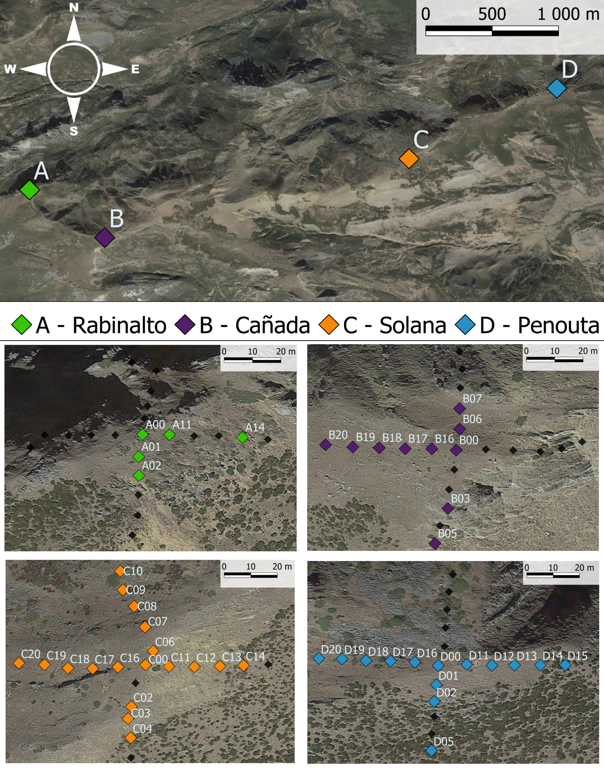

Fig 3. (A) Climogram of our study area, based on three of our summits Microlog SP3 data from July 2021 to June 2022. Lines in red represent monthly mean maximum and minimum temperatures; bars in grey represent the monthly mean of maximum ψb in Mpa. (B) Correlation graph between GDD and absolute sum of ψb registered. We used data from the growing season (April-November) of 2022 and 2023 in three of our summits, Cañada data is not complete and thus removed from visualization. (C) Principal Component Analysis of all 78 plots with environmental data, filtered according to iButtons recording specifications, each colour represents plots of a different summit.

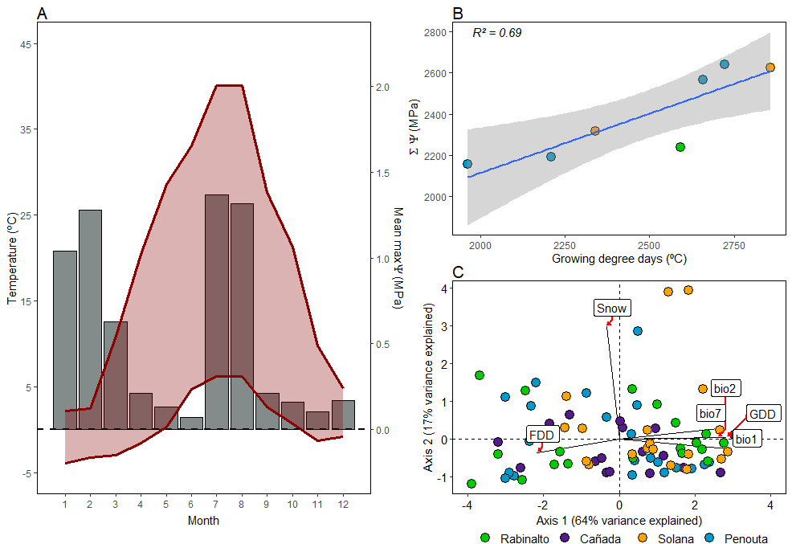

Fig 4. (A) Mean final germination proportion for both storage treatments in every water potential treatment (n subpopulations = 12 in both cases). Bottom panel (B): Cumulative germination curves from all subpopulations (N=12) for both storage treatments.

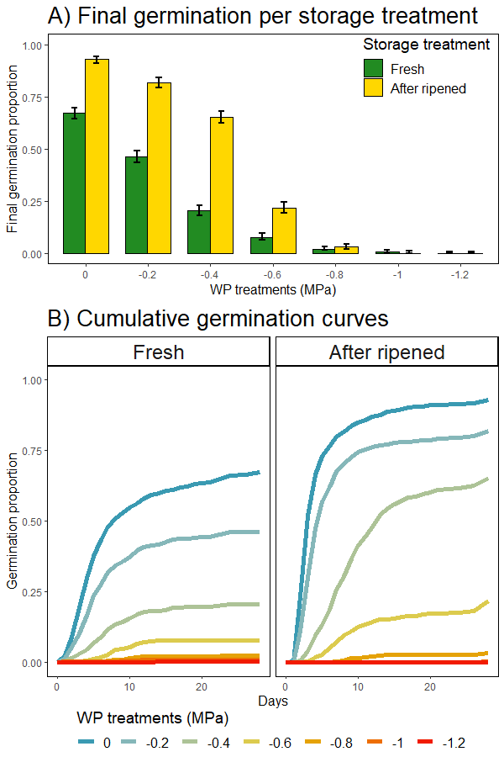

Fig 5. Base water potential calculated using seedr (Bradford method) for each subpopulation and their correlation with each subpopulation GDD. P-values from fitting a glmmTMB as explained in Methods.

